# Bitbot Test 1

In which category will you find the “show string” block?

A. Basic

B. Input

C. LED

D. Variables

ANSWER: A

What does the term ‘abstraction’ mean?

A. Breaking down the problem into small chunks

B. Removing unnecessary detail from the problem

C. Identifying patterns which could be used in the solution

D. Identifying step by step instructions to solve the problem

ANSWER: B

Which of the following is not a feature of a good algorithm?

A. Should be completed in as few steps as possible

B. Should produce a correct output for any correct input

C. Should be written in a high level language such as Python

D. Should always end

ANSWER: C

What is a light sensor an example of?

A. An output device

B. An input device

C. An input and output device

D. A storage device

ANSWER: B

What does an ultrasonic sensor measure?

A. Light levels

B. Distance

C. Acceleration

D. Movement

ANSWER: B

Simon has purchased bit:bot but cannot find the code blocks to program it. Which option should he click on to add necessary code library?

A. Functions

B. Arrays

C. Control

D. Extensions

ANSWER: D

What is the name of the device which is circled on the bit:bot?

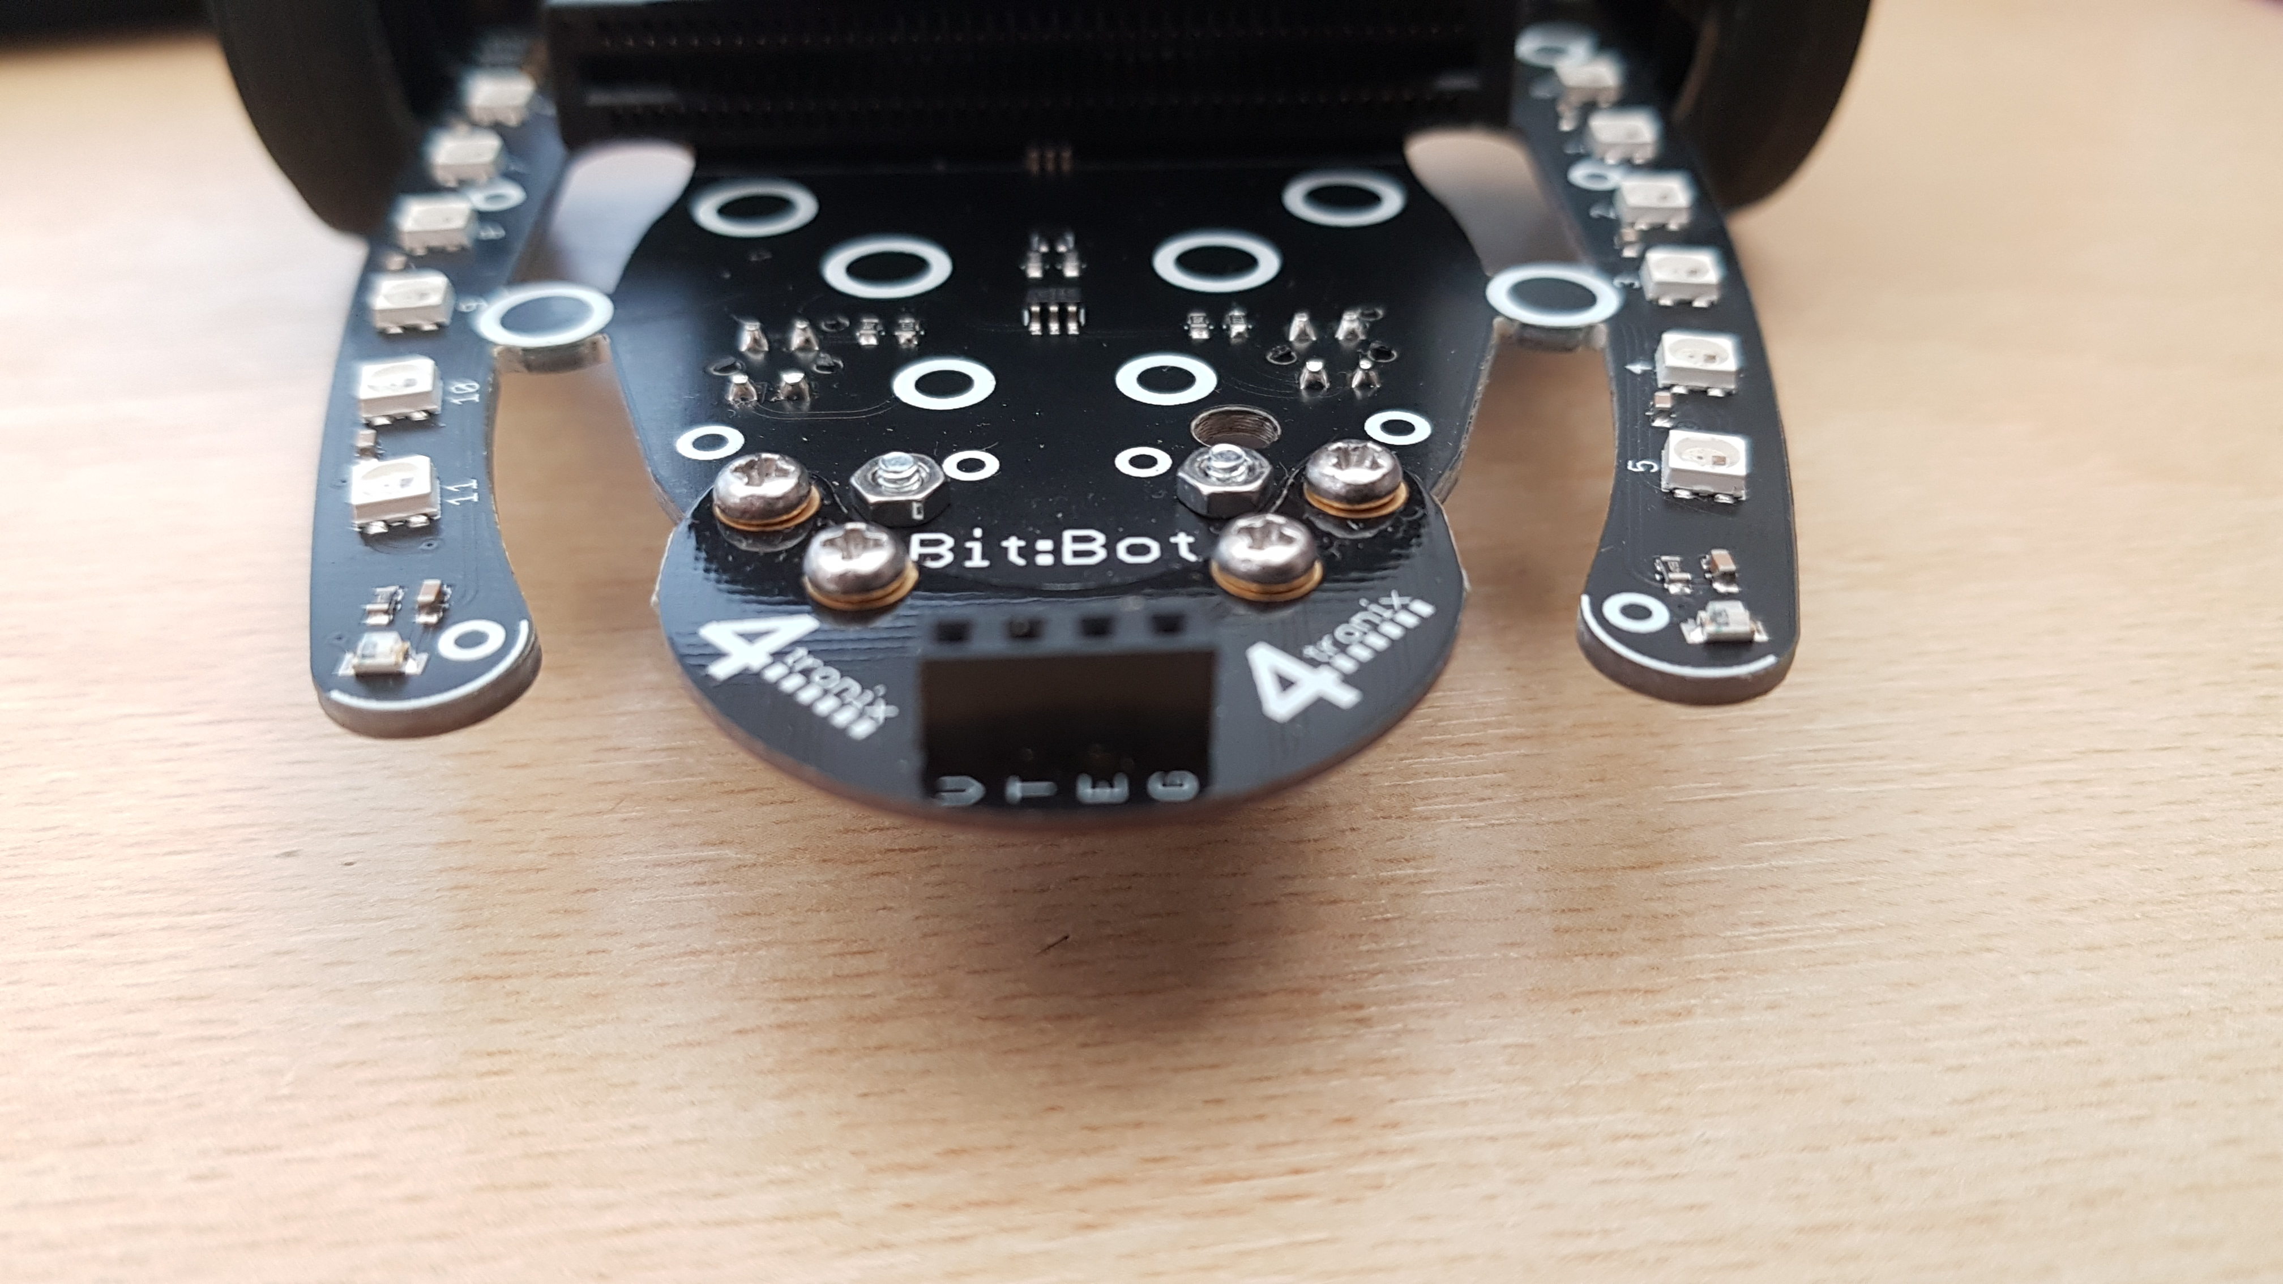

A. Light sensor

B. Ultrasonic sensor

C. LED Array

D. Servo

ANSWER: A

A bit:bot has been programmed to measure the light in a room. The relevant sensor has returned a value of 0. What does this mean?

A. The sensor isn’t working

B. The code is incorrect

C. It is very dark

D. It is very bright

ANSWER: C

The code below has been uploaded to the bit bot. What will happen?

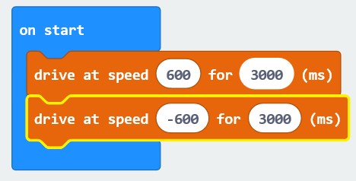

A. It will go forward and then stop

B. It will turn right

C. It will turn left

D. It will go forwards and then backwards

ANSWER: D

What is the name of the device which is circled below?

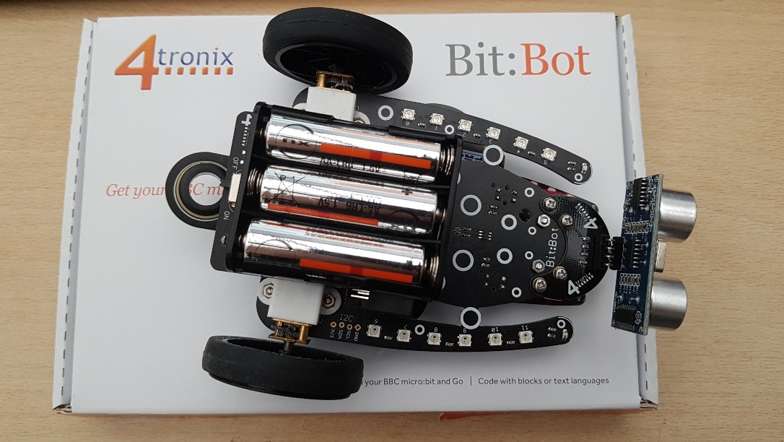

A. Motor

B. Light sensor

C. Neopixel

D. Microbit

ANSWER: C

The green code block creates a loop. What is the technical term for a loop?

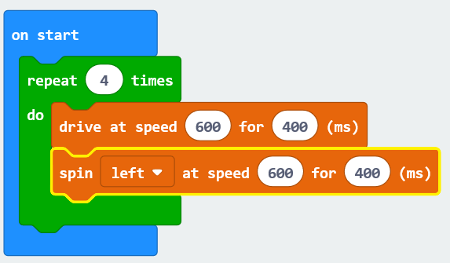

A. Sequence

B. Selection

C. Iteration

D. Rotation

ANSWER: C

What is the difference between the shift and rotate command when programming LEDs?

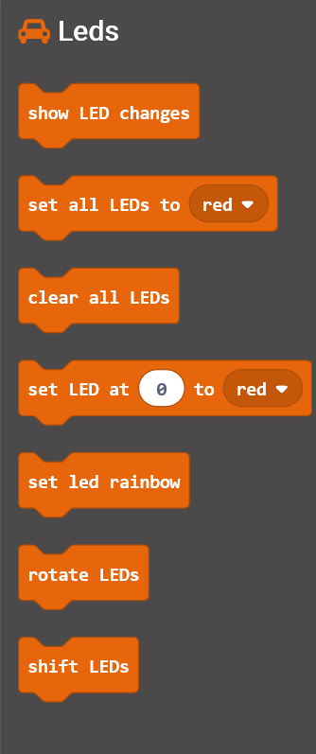

A. Shift rotates the LED forwards and stops at the end whereas rotate continues looping

B. Rotate rotates the LED forwards and stops at the end whereas shift continues looping

C. Rotate flashes all LEDs once and stops whereas shift continuously flashes all LEDs

D. Shift flashes LEDs in a straight line whereas rotates flashes LEDs in a circle

ANSWER: A

If the spin left command turns the bitbot 90 degrees left, what shape will the code below create?



A. Circle

B. Square

C. Rectangle

D. Polygon

ANSWER: B

How could the code below be rewritten so that it uses less memory?

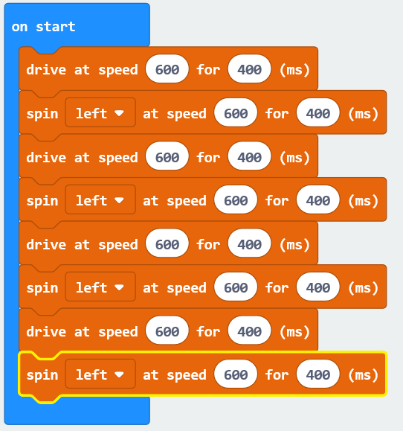

A. Use sequence

B. Use selection

C. Use iteration

D. Increase the speed

ANSWER: C

Which of the following statements correctly describes the block of code below?

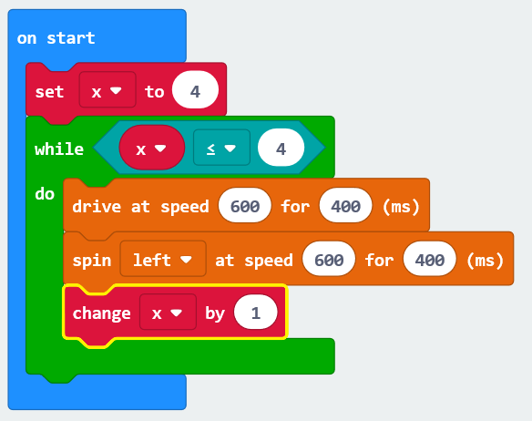

A. It contains a count controlled loop

B. It contains a condition controlled loop

C. It only uses examples of sequence

D. It only uses examples of selection

ANSWER: B

A self-driving car has been designed so that if a pedestrian steps out it is detected by the car. What is used to detect the person?

A. A sensor

B. An output device

C. A process

D. A storage device

ANSWER: A

Janine is designing a new finance system. She has split the overall task into the following sub tasks – invoicing, payments, ordering and reporting. What is this an example of?

A. Abstraction

B. Algorithmic thinking

C. Pattern identification

D. Decomposition

ANSWER: D

When starting a washing machine the user selects the program. The washing machine then turns on the water and spins the drum. What is the step known as when the user selects the cycle?

A. Input

B. Process

C. Output

D. Storage

ANSWER: A

What is the motor on the bit:bot an example of?

A. An input device

B. An output device

C. An input and output device

D. A storage device

ANSWER: B

A bitbot has been programmed to go forward one step and then turn 1 degree. These two steps have then been repeated 360 times. What shape would be followed?

A. A square

B. A rectangle

C. A pentagon

D. A circle

ANSWER: D